You Want To Be Grass

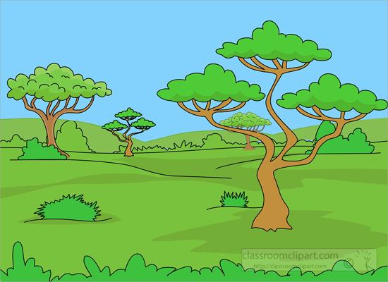

Oh yeah, oh yeah, uh huh uh huh

We’re eaten by the antelope
For zebra’s we’re a feast, oh yeah
We’re called lunch and dinner by the wildebeest, uh huh
We’re stomped on by the elephant
You know what hippos weigh? Oh yeah
Lions lyin’ on us every single day

You want to be grass? Be grass? Be grass?
Savannas are no putting green
You want to be grass? Be grass? Be grass?
Oh-we’re just cuisine

They’re termite mounds and zebra hooves
Hyenas laugh at you, oh yeah
We just have to take it, what else can grass do? Uh huh
So if you are not trampled on
You’re likely to be chewed, oh yeah
On the Serengeti we’re the steady food

You want to be grass? Be grass? Be grass?
Savannas are no putting green
You want to be grass? Be grass? Be grass?
Oh-we’re just cuisine
Oh-we’re just cuisine

