Close to Shore

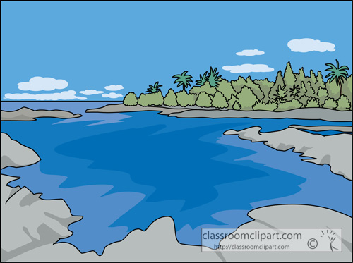

‘Cause out in these waters
There’re floating sea otters
The whale and dolphin and shark
And deep in the ocean
There’re weird things in motion
And creatures that glow in the dark

It’s nasty, oh brother-
They’re eating each other!
And there isn’t one without scars
Our tide pool’s not taxing
We sit here relaxing
Where starfish are always the stars

Close to shore, close to shore
Stuck right here, evermore
In this tide pool we’re nobody’s fool
Close to shore

It’s nasty, oh brother-
They’re eating each other!
And there isn’t one without scars
Our tide pool’s not taxing
We sit here relaxing
Where starfish are always the stars

Close to shore, close to shore
Stuck right here, evermore
In this tide pool we’re nobody’s fool
Close to shore

